

INtegration service interface specification

© The Marlborough Stirling Canada 2007

Version: 1.0

March 29, 2007

CONTENTS
Revision History iii
1 Introduction 1
1.1 Audience 1
2 Technical Specification 2
2.1 Integration Service as a Service Provider 2
2.2 Integration Service as a Consumer 3
2.3 Technical Support and Testing 3
3 Security 4
Appendix 5

Revision History

Date | Version | Description | Author | Reviewed By
Mar 29, 2007 | 1.0 | Initial Document | Nagesh Chawla

Introduction
Integration Service is a published web service that provides messaging functionality between Marlborough Stirling Canada’s (MSC) internal systems such as MorWEB, Omiga and Optimus and external systems with MSC’s trading partners such as lenders and insurance companies. This is a generic service that acts as both service provider and consumer, thus providing a unified end point for trading partners.

This document provides general overview of the service, messaging protocols and data exchange format. The intent of the document is to provide specification on how to consume and integrate with the Integration Service.

Audience
The audiences of this document are:
- Architects, who are responsible for designing service consumers,
- Systems Analysts, who are responsible for designing data schemas,
- Programmer analysts, who are responsible for developing service consumers.

Technical Specification
The Integration Service is a published web service built using industry standard protocols and messaging mechanisms, such as, SOAP, WS-Security and WSDL. It is a generic messaging mechanism built on ESB paradigm. It acts as both service provider and service consumer.

Integration Service as a Service Provider
The service acts as service provider for external systems that can send application data and/or insurance data. The service can be access using SOAP protocol. It exposes a generic operation called “ProcessRequest” that the external systems can call when sending data.

The following sequence diagram illustrates consuming the service from external systems:

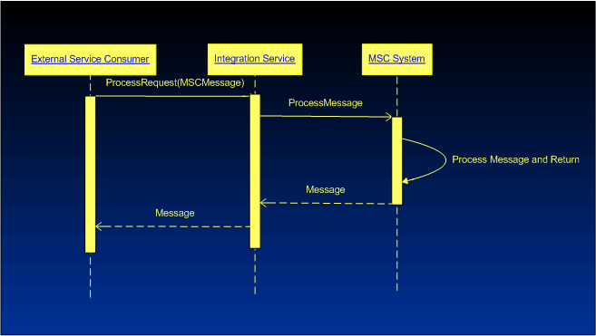
Figure 1: Sequence Diagram for ProcessRequest Operation

When an external system intends to integrate with MSC’s internal systems, it would consume MSC’s Integration Service via its own service consumer. The service consumer calls Integration Service’s ProcessRequest method while passing MSCMessage type as parameter. The MSCMessage type is an XML document, the schema for which is a provided in the appendix. The schema is a generic shell that encapsulates any request related XML data within it. The consumer must, however, provide the following data elements within the generic MSCMessage schema, apart from request related data:
- requestId
- serviceType
- provider
- source
- recipient

The schema details, mapping related information, values for the above data elements along with any enumerations within the schema will be given by MSC team during integration project, between MSC and consuming party. The initial details are provided in the appendix section of this document.

Further, URL and WSDL for the service will also be provided by the team. Note that the URL will be different for different environments within MSC. Please contact the team for the details.

Integration Service as a Consumer

The Integration Service is also a service consumer and can consume services exposed by MSC’s trading partners. The service can consume partner services over various protocols such as SOAP, HTTP, FTP, etc.

The service can provide data in the format the integrating trading partner requires. The details of data schema involved should be provided to MSC during integration project.

Technical Support and Testing

MSC’s technical team will provide complete guidance and assistance for consuming the service. During the integration project, the team will also assist with required data mappings between MSC’s service and trading partner domains. The team will also assist with testing and technical issues.

Security
The Integration Service is a secured service. The service security is implemented using MSC preferred WS-Security standard. Amongst the three token types of the standard, the service implements Username token mechanism to authenticate incoming requests.

Service consumers will send MSC supplied credentials according to the OASIS specification as described below:

- Send username token containing user id, supplied by MSC.
- Send hashed password supplied by MSC as follows:
Password_digest = Base64 (SHA-1(nonce + create time + password))

Further, the service implements transport level security using SSL. Consumers should use HTTPS protocol to consume the service.

Appendix

A. MSC specific MSCMessage type schema:

<?xml version="1.0" encoding="utf-16" ?>
- <xs:schema xmlns:b="http://schemas.microsoft.com/BizTalk/2003" attributeFormDefault="unqualified" elementFormDefault="qualified" targetNamespace="http://mscanada.com" xmlns:xs="http://www.w3.org/2001/XMLSchema">
- <xs:element name="clipboard">
- <xs:complexType>
- <xs:sequence>
- <xs:element name="context">
- <xs:complexType>
<xs:attribute name="applicationName" type="xs:string" use="required" />
<xs:attribute name="sessionId" type="xs:string" use="optional" />
<xs:attribute name="userid" type="xs:string" use="optional" />
<xs:attribute name="language" type="xs:string" use="required" />
<xs:attribute name="dateTime" type="xs:string" use="required" />
</xs:complexType>
</xs:element>
- <xs:element name="request">
- <xs:complexType>
- <xs:sequence>
<xs:element name="comment" type="xs:anyType" />
- <xs:element name="errors">
- <xs:complexType>
- <xs:sequence>
- <xs:element minOccurs="0" name="error">
- <xs:complexType>
<xs:attribute name="code" type="xs:string" use="optional" />
<xs:attribute name="message" type="xs:string" use="optional" />
</xs:complexType>
</xs:element>
</xs:sequence>
</xs:complexType>
</xs:element>
</xs:sequence>
<xs:attribute name="requestId" type="xs:string" use="required" />
<xs:attribute name="serviceType" type="xs:string" use="required" />
<xs:attribute name="source" type="xs:string" use="required" />
<xs:attribute name="provider" type="xs:string" use="required" />
<xs:attribute name="recipient" type="xs:string" />
</xs:complexType>
</xs:element>
<xs:element minOccurs="1" maxOccurs="1" name="applicationData" type="xs:anyType" />
</xs:sequence>
</xs:complexType>
</xs:element>
</xs:schema>

B. AIG specific mappings:

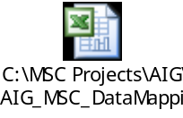

C. Service WSDL:

To be included.

